Pizza Sales Data Analysis Report

Author: Ithihas Kandi
Date: September 26, 2025
Location: MySQL Workbench, India

Abstract
This report presents an in-depth analysis of pizza sales data, comprising 48,620 transactions with 12 key attributes including order details, pizza variants, quantities, and revenue. The analysis aims to uncover sales trends, customer purchase behaviour, and product performance insights using SQL queries on a MySQL database. These insights enable strategic business decisions to optimize sales and improve customer satisfaction.

Table of Contents
Introduction 2
Exploratory Data Analysis (EDA) 2
Business Questions 4
Conclusion 11

Introduction
Pizza sales data offer rich insights into customer preferences, effective product offerings, and temporal sales variations. Analysing this data helps identify best-selling products, optimal pricing strategies, and peak sales periods. This project imports the pizza sales dataset into MySQL Workbench and applies various SQL queries to explore and summarize the data. Results include total revenue, sales by pizza size and category, monthly and daily trends, and ranking of products by quantity and revenue.

Exploratory Data Analysis (EDA)
The structure and content of the dataset
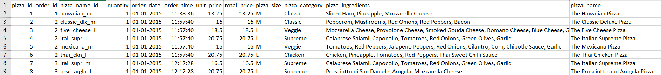
Source: https://www.kaggle.com/code/mdismielhossenabir/pizza-sales-dataset
The dataset contains 48,620 rows and 12 columns, including pizza identification, quantity, order timing, pricing, size, category, ingredients, and names, providing a comprehensive view for sales analysis.

Importing data into MySQL
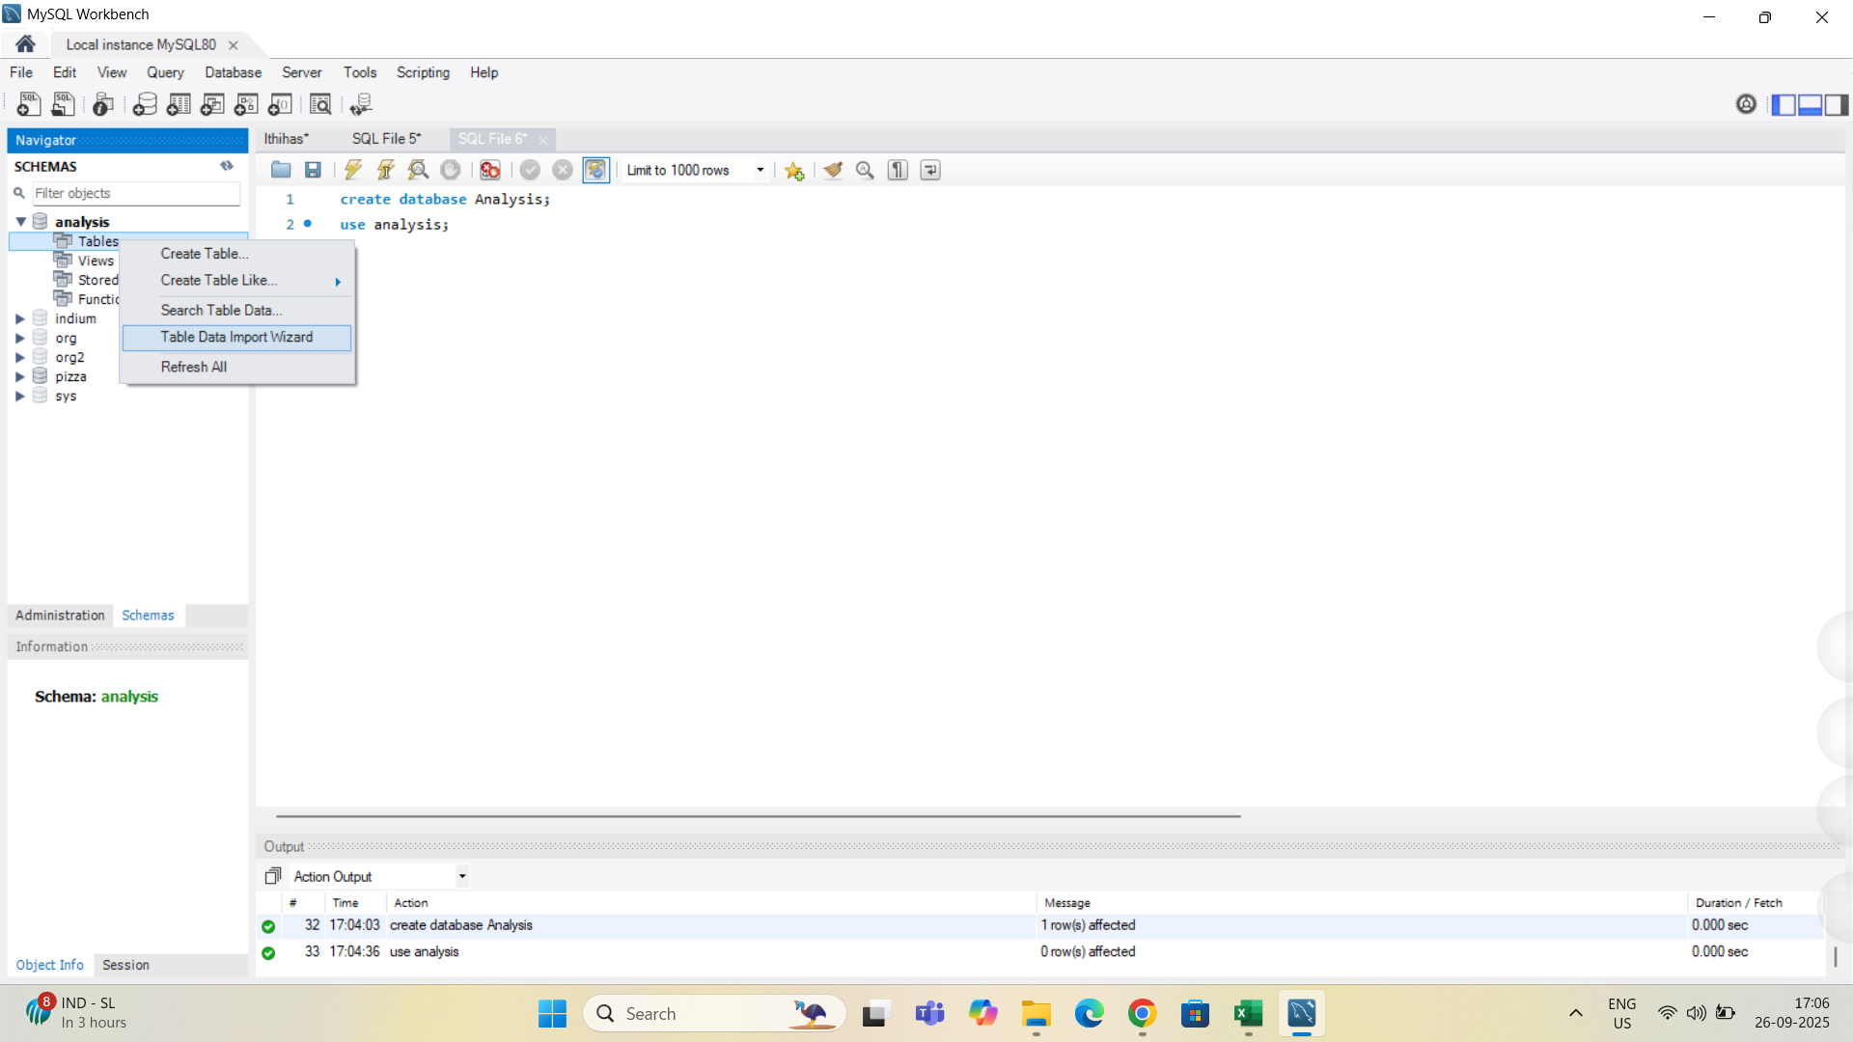
The "analysis" database schema was created and selected to organize data and facilitate query execution. Data import was conducted using MySQL Workbench's Table Data Import Wizard into ‘Analysis’ database by creating ‘pizza_sales’ table, ensuring correct schema mapping.

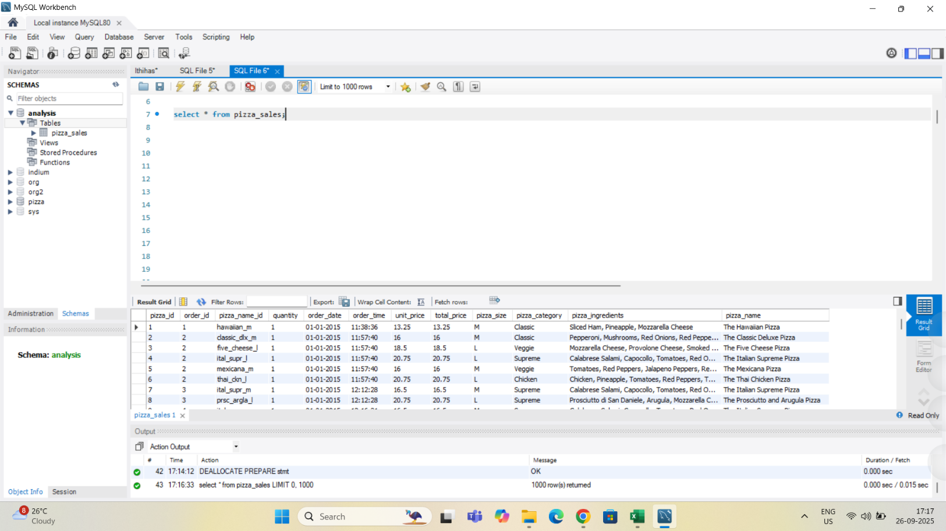
Verified with a sample select query showing all columns correctly imported, ready for analytical querying.

Changing Data Types
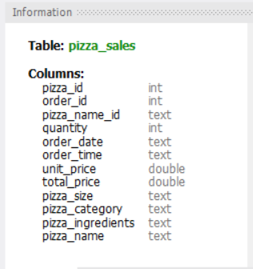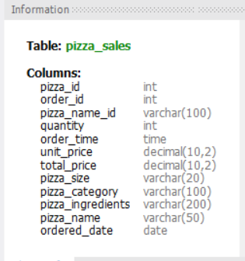

Business Questions
Business Question 1: What is the total revenue from pizza sales?
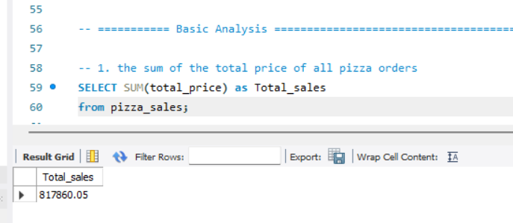
Aggregate sales amount was calculated, revealing total revenue of 817,860.05 over the data period.

Business Question 2: How many pizzas were sold?
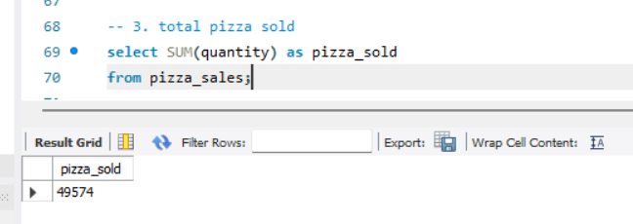
Summing quantities gives a total of 49,574 pizzas sold, indicating product volume.

Business Question 3: What is the average spending per order?
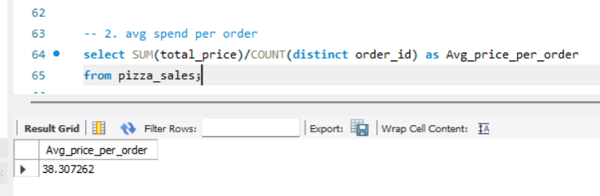
Mean aggregate price per distinct order calculated as 38.31, key for revenue and pricing insights.
Business Question 4: How many unique orders were placed?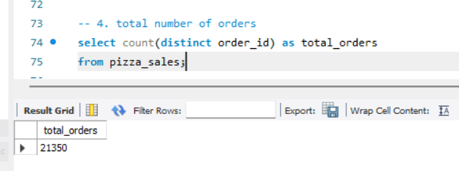
Unique orders count stands at 21,350, reflecting business transaction volume.

Business Question 5: How do sales distribute by day of the week?
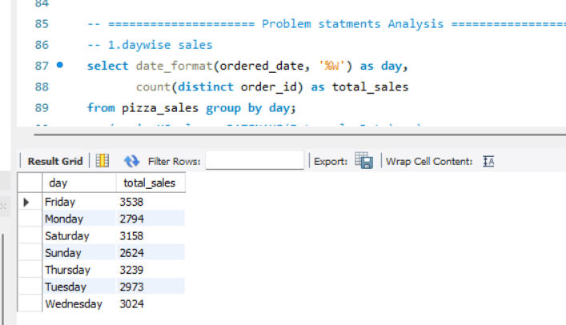
Highest sales observed on Fridays, lowest on Sundays, informing staffing and promotional plans.

Business Question 6: What are monthly sales trends?
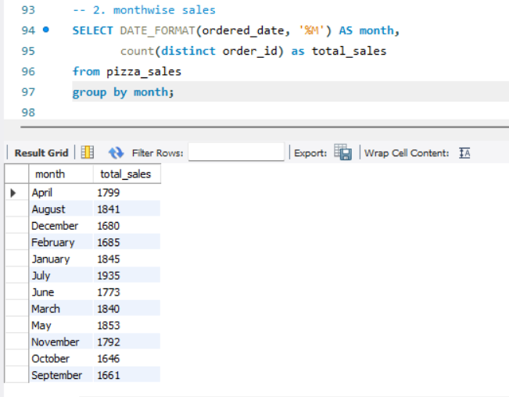
Sales volumes fluctuate, with peaks in April and January, useful for seasonal inventory planning.

Business Question 7: What is the percentage of sales by pizza size?
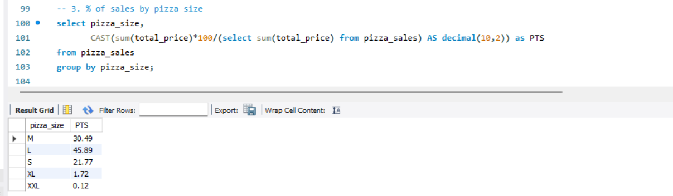
'Large' pizza accounts for the highest sales percentage (45.89%), indicating size popularity.

Business Question 8: How many pizzas sold by category?
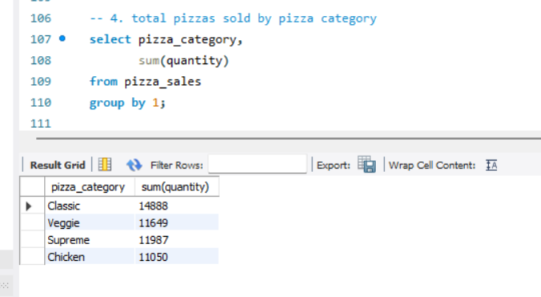
'Classic' category leads in quantity sold, followed by 'Veggie', 'Supreme', and 'Chicken'.

Business Question 9: Who are the top 5 best sellers by quantity?
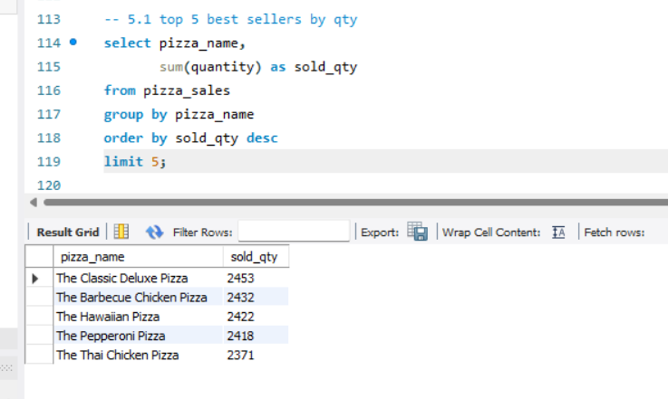Classic Deluxe and Barbecue Chicken are among the highest selling pizzas by volume.

Business Question 10: Who are the top 5 best sellers by revenue?
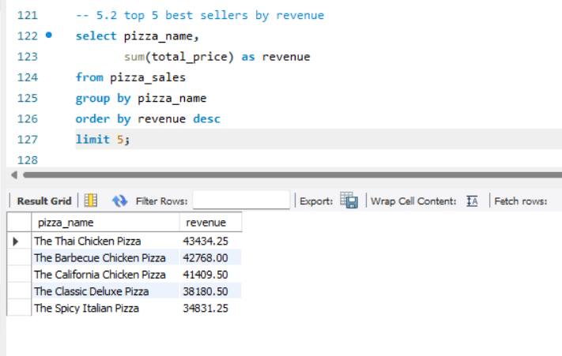Revenue leaders include Thai Chicken and Barbecue Chicken, guiding focus for high-revenue products.

Business Question 11: Who are the top 5 pizzas by order count?
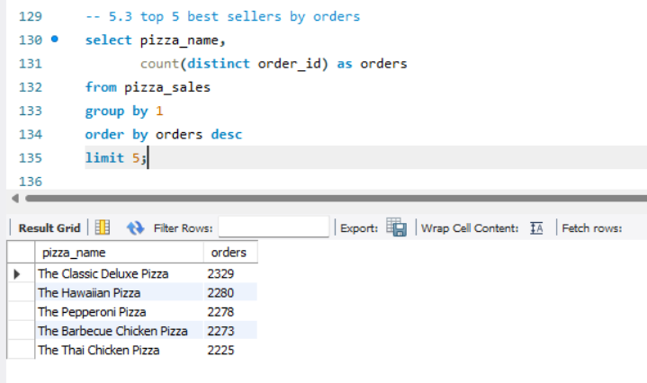Classic Deluxe Pizza topped order counts, indicating strong customer preference.

Business Question 12: Who are the bottom 5 pizzas by quantity?
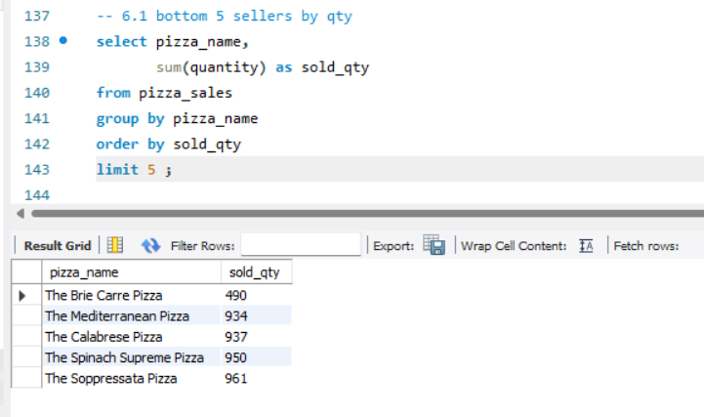Identified lower demand pizzas to consider for menu optimization.

Business Question 13: Who are the bottom 5 pizzas by revenue?
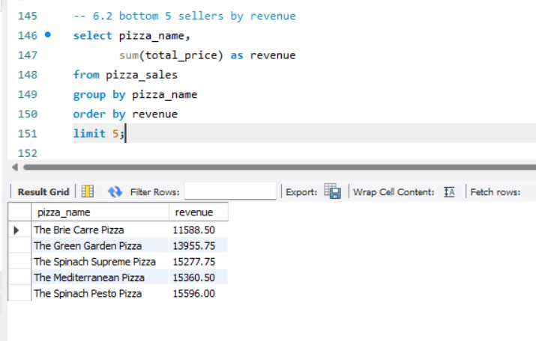Low revenue pizzas suggest candidates for marketing or discontinuation review.

Business Question 14: Who are the bottom 5 pizzas by orders?
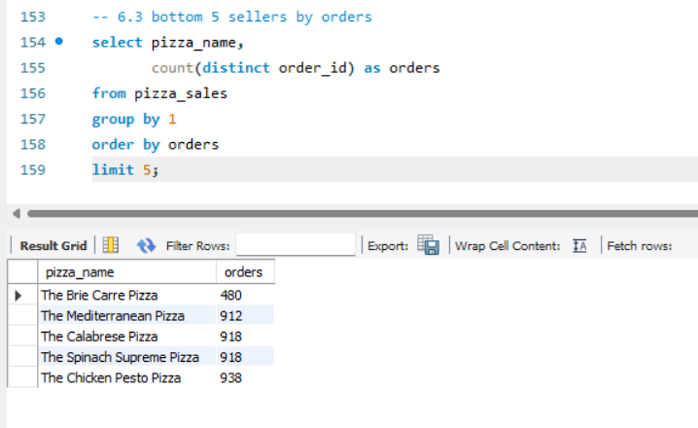This highlights low order-frequency pizzas for focus.

Conclusion
The analysis provides an extensive view of pizza sales dynamics, customer preferences, and business performance metrics. Insights on best-selling products, sales seasonality, and customer ordering patterns equip stakeholders to tailor marketing campaigns, adjust inventory, and optimize revenues. Future work includes deeper predictive analytics and customer segmentation for enhanced strategic planning.

